James W. Smith
January AIG Newsletter
I hope everyone had a wonderful holiday break and is ready to get back to work.
I am at JWS all day Wednesday and Thursday mornings through January 21st. After the 21st I will only be at JWS on Wednesdays. Since I am not at school on a regular basis, the easiest and fastest way to contact me is through email. (tina.west@cravenk12.org )
Each of my classes has a Google classroom. If you would like to see what your student is working on in AIG, please ask your student to login to his/her Google classroom at home.
Please visit my website at http://jwswest.weebly.com/ .

Reading Scholars:  Both 4th and 5th grade reading scholar groups are working on selections from Junior Great Books. The Junior Great Books (JGB) program uses a method of interpretive reading and discussion known as Shared Inquiry. Students explore each selection through a sequence of activities that includes two readings, directed note taking, Shared Inquiry discussion, and writing.  4th Grade Scholars is working on “Tuesday of the Other June” by Norma Fox Mazer. This is a story about a girl who has trouble with a bully.  5th Grade Scholars is working on “Turquoise Horse” by Gerald Hausman. This story is about a girl who has a dream related to her Navajo ancestry and her confidence or lack of confidence about sharing her dream.  Both grades are expected to:  - Generate ideas in response to an interpretative question  - Provide evidence that supports their answers  - Respond with an awareness of other students’ ideas, questions, and arguments | Socratic Scholars:  We are still working on the engineering unit titled The Attraction is Obvious: Designing Maglev Systems. This is an engineering unit from the National Center for Technological Literacy. In this unit, students will explore the connections between the properties of magnets, the technological innovation of the maglev train, and the field of transportation engineering. We will most likely be working on this unit December and January.  We are finishing up Lesson 1 which we started before the holidays. Below are the lesson we will be working on. These lessons take several class periods to complete. I am sure we will not finish in January.  Lesson 1: Engineering Story  This lesson sets the context for the unit through the story Hikaru’s Toy Troubles.  Lesson 2: A Broader View of the Engineering Field  Through hands-on activities, students learn more about the types of work done by engineers.  Lesson 3 Scientific Data Inform Engineering Design  This lesson helps students understand the linkages between science, math, and engineering. Students will collect and analyze scientific data that they can refer to in Lesson 4.  Lesson 4: Engineering Design Challenge  Following the steps of the Engineering Design Process, students design, create, and improve solutions to an engineering problem.

4th Grade Math Scholars:

In 4th grade math scholars we use No Problem! Taking the Problem Out of Mathematical Problem Solving. Students cover eight problem solving strategies. They are:

1. Guess and check 5. Simplify or work backwards
2. Make a table 6. Make a diagram or drawing
3. Make an organized list 7. Act out or use manipulatives
4. Look for a pattern 8. Use logic

Students are presented with six problems for each strategy. The problems get progressively more difficult as they work through them. Students have to share how they solve the problems with the class. The students have completed the first three strategies. We are finishing up the 5th strategy. Once finished we will begin strategy 6. The problems they are currently working on are posted on the AIG 4th Grade Math Google Classroom.

Below is an example of one of the problems from Strategy 6.
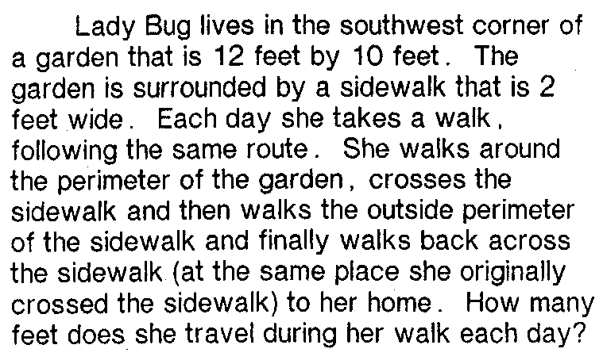

5th Grade Math Scholars:
In 5th grade math scholars we use Challenging Common Core Math Lessons for Gifted and Advanced Learners Gr. 5. Below is part of a lesson practice the students will be completing this month. The entire handout and questions are posted on the 5th Grade AIG Google Classroom.

Lesson objectives:
- generate patterns based on rules
- determine relationships between numbers
- graph ordered pairs on coordinate grids

